# 

# 

# 

# 

# 

# **XYZ Chatting App**

# Group 3

# Centennial College

# Web Application Development - COMP 229 - 001

# Blessing Ajiboye

# 

# 

# 

# 

# 

# 

# 

# 

# 

# 

# 

**1. Introduction 3**

1.1 Purpose of the Document 3

**2. Functional Overview 3**

2.1 Features Implemented 3

2.2 Functionality Highlights 3

**3. Visual Design 3**

3.1 Color Scheme 3

3.2 Fonts 4

3.3 Navigation Design 4

3.4 Authentication Strategy 4

**4. Deployment Overview 4**

4.1 Front-End Deployment 4

4.2 Back-End Deployment 5

4.3 Database Deployment 5

**5. Wireframes and Screenshots 6**

5.1 Home/Landing Page with Nav Bar 6

5.2 Sign Up Page 6

5.3 Sign In Page 6

5.4 My Profile Page 7

5.5 Users Page 7

5.6 Chatting Feature 7

**6. Project Demo 8**

6.1 Project Demo 8

**7. Conclusion 8**

7.1 Summary of Achievements 8

7.2 Challenges Faced and Overcome 8

7.3 What Went Well 8

7.4 What Was Challenging 8

7.5 Future Improvement 9

# 

# Introduction

## 1.1 Purpose of the Document

This document serves as a comprehensive guide to the final release of our web application. It outlines the functional and visual aspects of the application, deployment details, and the team's progress throughout the development process.

# Functional Overview

## 2.1 Features Implemented

* **SignUp and SignIn**: Users can easily create an account by signing up and subsequently log in to access the full range of functionalities.
* **My Profile and Users**: The web application includes a comprehensive user profile system, allowing individuals to manage and customize their personal information. Users can also explore and interact with other profiles.
* **Chatting Feature**: The implemented chatting feature enables real-time communication between users, fostering seamless interaction and collaboration within the platform.

## 2.2 Functionality Highlights

* **Account Management**: Our SignUp and SignIn features are designed with user convenience in mind, ensuring a straightforward and secure process for account creation and login.
* **Profile System**: The My Profile and Users functionalities provide a rich and customizable user experience, allowing individuals to showcase their information and connect with others in a meaningful way.
* **Chatting Experience**: The web app's Chatting Feature enhances user engagement by facilitating instant communication. Whether for personal connections or professional collaborations, the chatting feature offers a dynamic and responsive platform for seamless interaction.

# Visual Design

## 3.1 Color Scheme

The chosen color scheme for our web application revolves around shades of purple. This includes a primary deep purple for the background, complemented by lighter purples and lavender for accents and highlights. The color swatches are as follows:

* **Primary Background**: #4A148C (Deep Purple)
* **Accent Highlights**: #7E57C2 (Light Purple)
* **Additional Accent**: #E1BEE7 (Lavender)

## 3.2 Fonts

The main font used throughout the site is Roboto. Roboto offers a clean and modern aesthetic, contributing to a readable and visually appealing user interface. It is applied consistently across headers, paragraphs, and other text elements to maintain a cohesive design.

## 3.3 Navigation Design

The navigation structure is designed for simplicity and ease of use. The main menu includes the following options:

1. **Sign Up**: Allows users to create a new account.
2. **Sign In**: Provides access for existing users to log in.
3. **Users**: Navigates to a section where users can explore and interact with others.
4. **My Profile**: Takes users to their personal profile page for customization and management.
5. **Log Out**: Enables users to securely log out of their accounts.

This straightforward navigation design ensures users can access key features with minimal effort.

## 3.4 Authentication Strategy

For user security, the implemented authentication strategy includes a robust 2-factor authentication (2FA) method. This additional layer of security enhances the protection of user accounts by requiring a secondary verification step beyond the traditional username and password. Users can expect a heightened level of account protection through this authentication strategy.

# Deployment Overview

## 4.1 Front-End Deployment

To mitigate CORS and other security issues during front-end deployment, we followed these steps:

* **Separate Domain**: The front-end, built using JavaScript and React, was deployed on a different domain or subdomain from the back-end. This helps avoid CORS issues.
* **CORS Configuration**: The back-end server was configured to allow specific origins, ensuring that only authorized domains could make requests.
* **HTTPS Usage**: Deploying the front-end over HTTPS adds an additional layer of security, especially when interacting with APIs on different domains.

## 4.2 Back-End Deployment

The back-end deployment process involved leveraging a cloud provider for hosting and managing the Express server and associated technologies. The steps included:

* **Server Deployment**: The Express server, responsible for handling API requests, was deployed on the chosen cloud infrastructure.
* **JWT Implementation**: The JSON Web Tokens (JWT) for authentication were integrated into the deployment, ensuring secure communication between the client and server.
* **WebSocket Integration**: Socket.IO, which facilitates real-time communication, was deployed alongside the Express server to enable seamless chat functionality.

## 4.3 Database Deployment

For deploying the MongoDB database, a cloud-based provider was chosen for scalability and ease of management:

* **Cloud Database Service**: Utilizing a cloud-based MongoDB service, such as MongoDB Atlas, simplified the deployment and management of the database.
* **Configuration and Connection**: The Express server's connection to the MongoDB database was configured securely, with appropriate access controls and connection strings.
* **Serverless Database Consideration**: Depending on the provider, serverless database options were explored to optimize resource utilization and cost efficiency.

# Wireframes and Screenshots

## 5.1 Home/Landing Page with Nav Bar

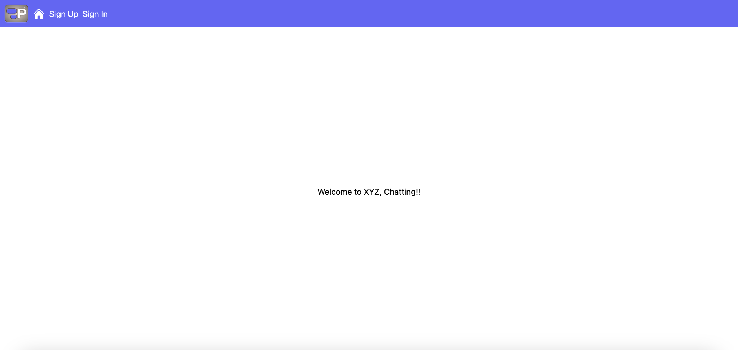

## 5.2 Sign Up Page

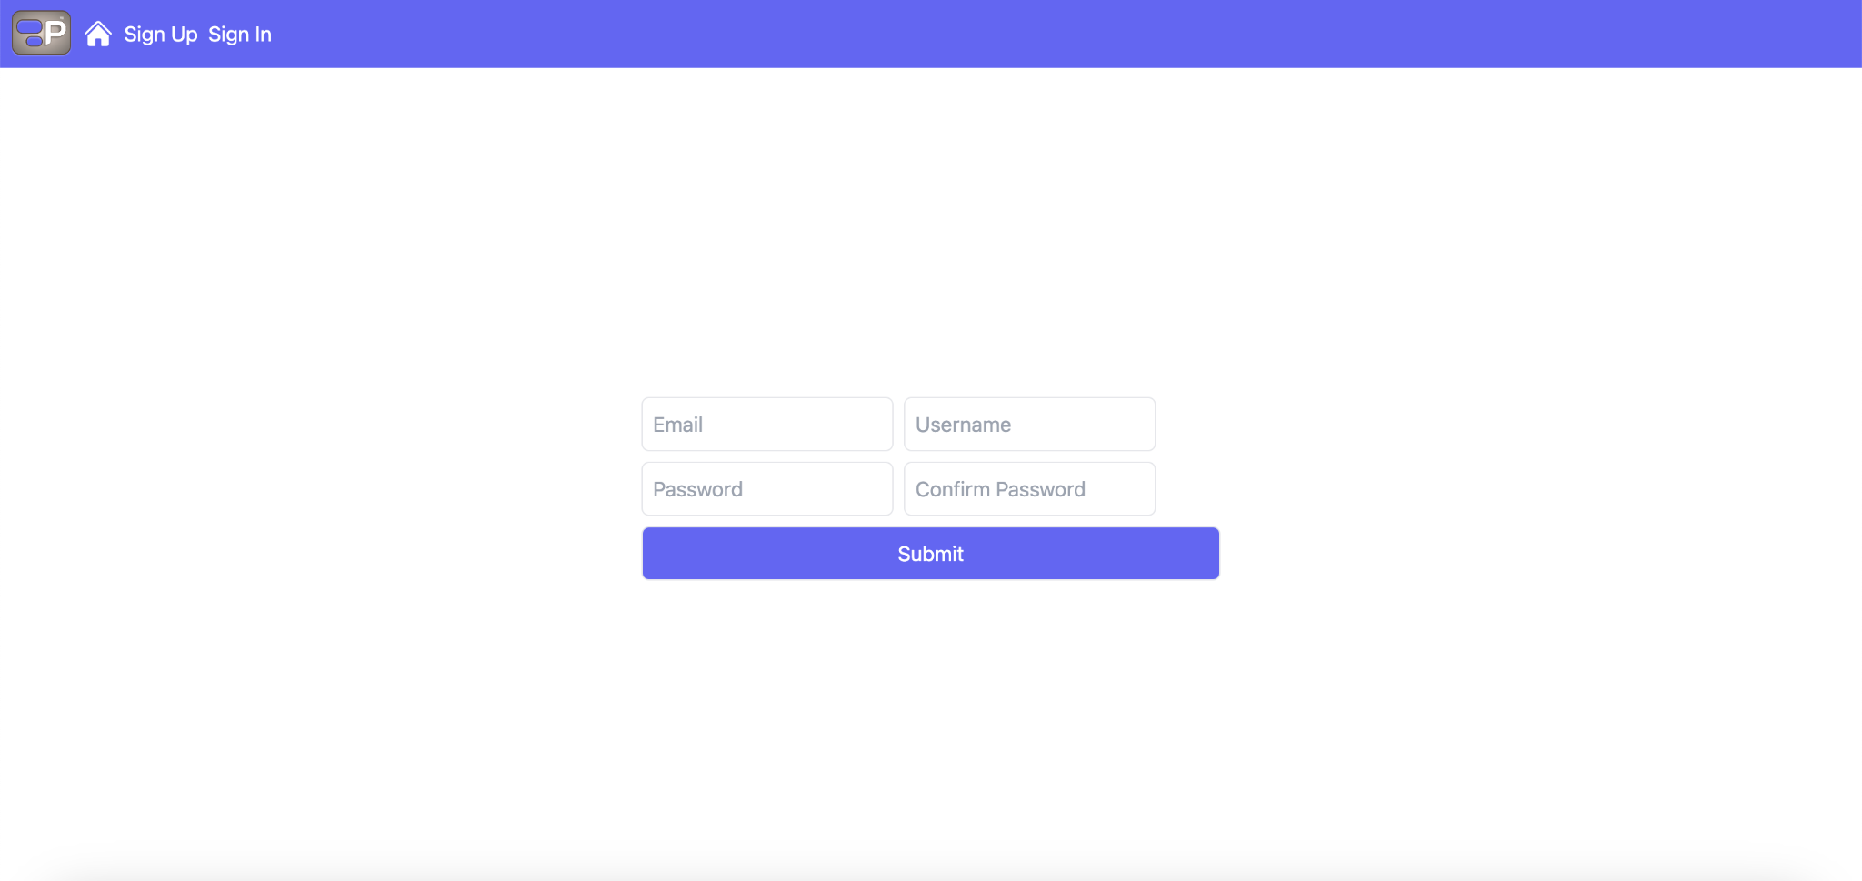

## 5.3 Sign In Page

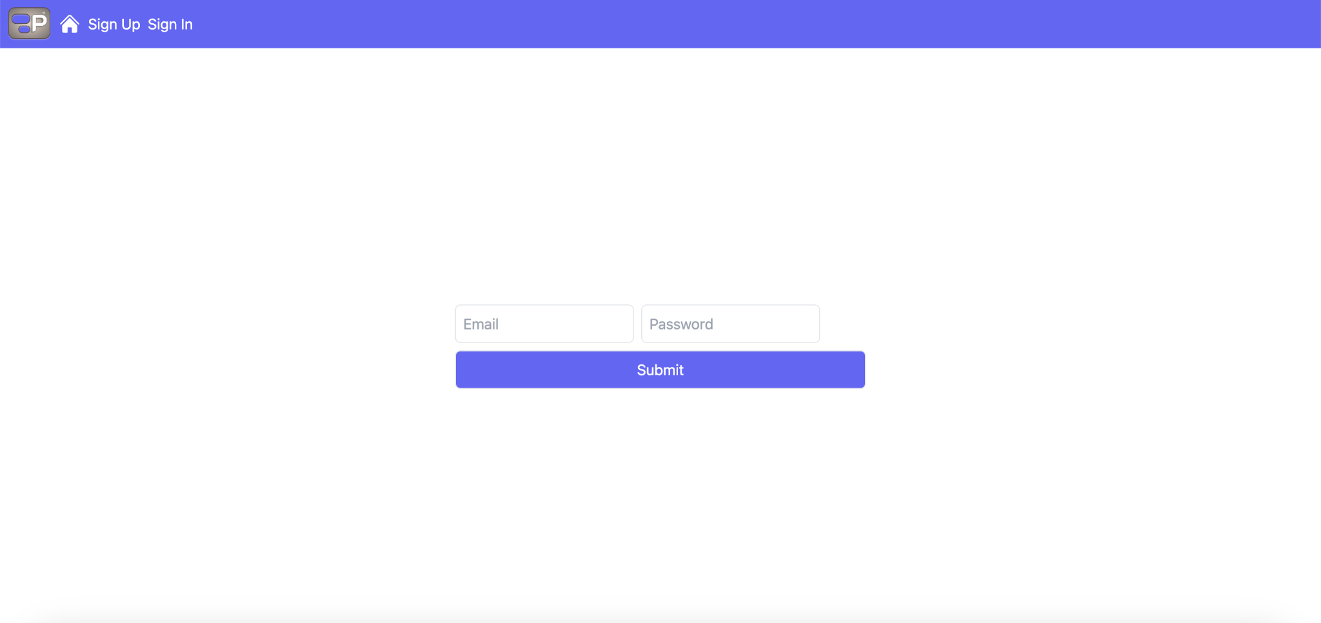

## 5.4 My Profile Page

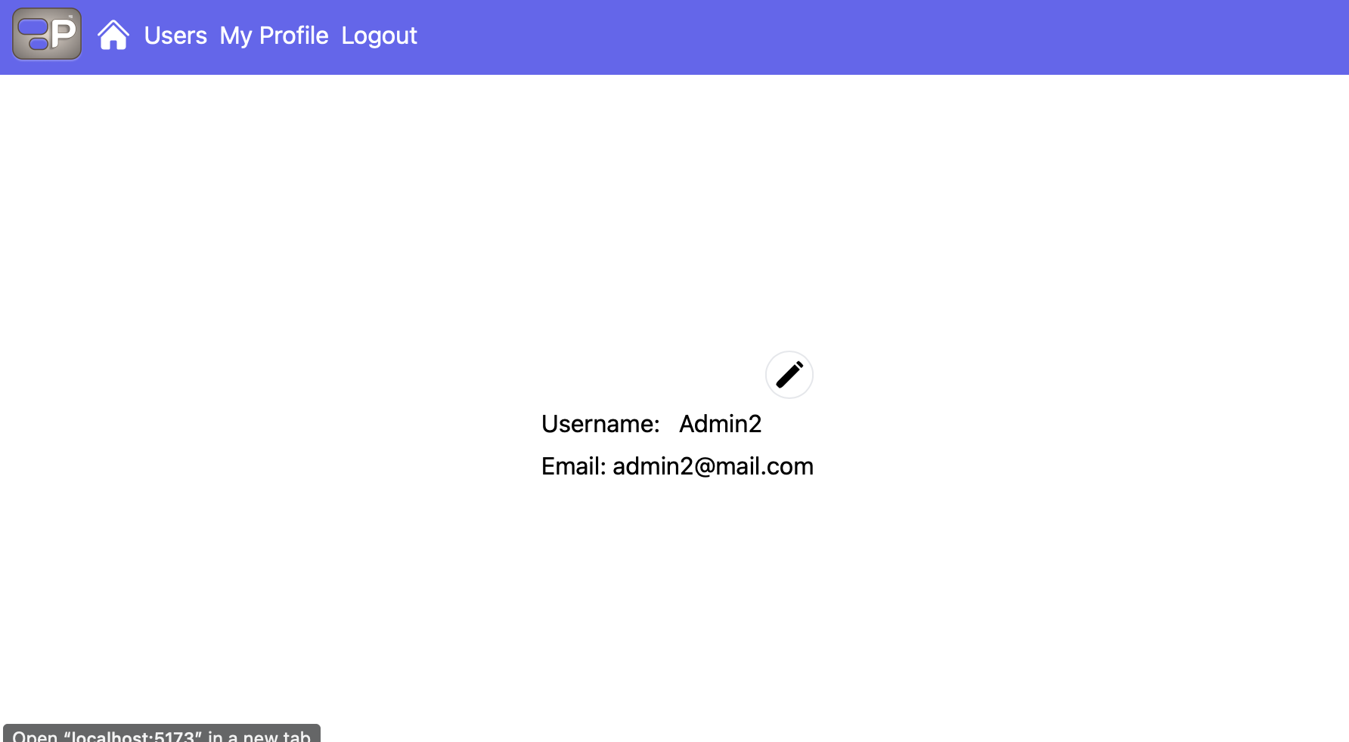

## 5.5 Users Page

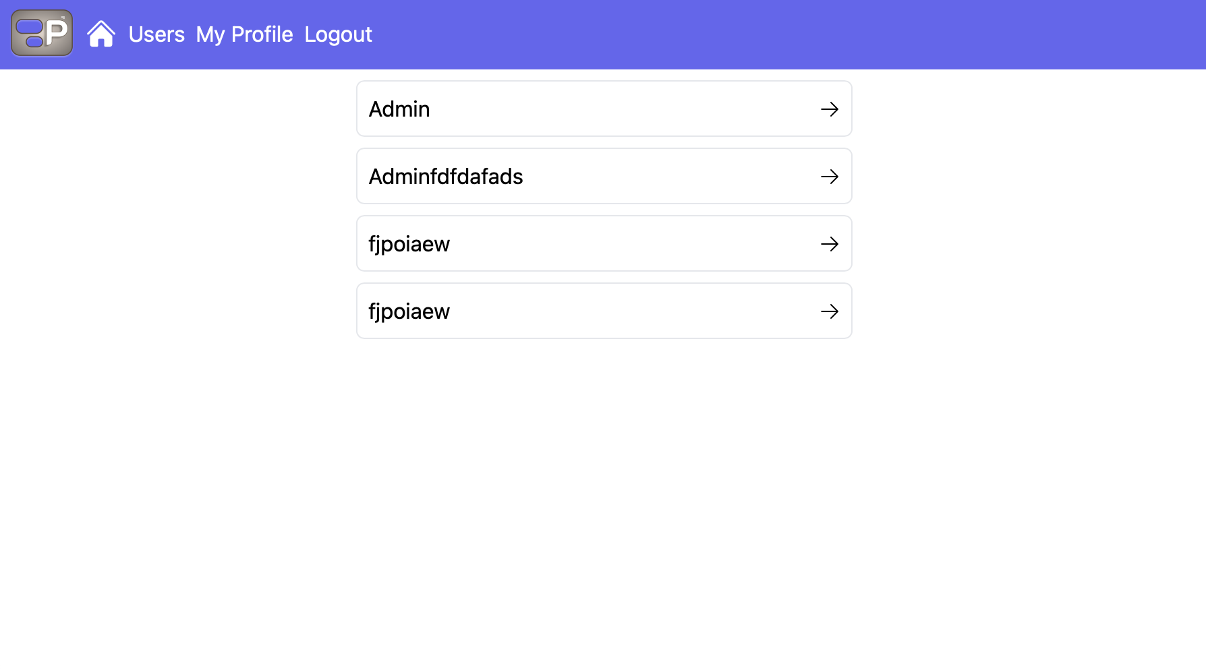

## 5.6 Chatting Feature

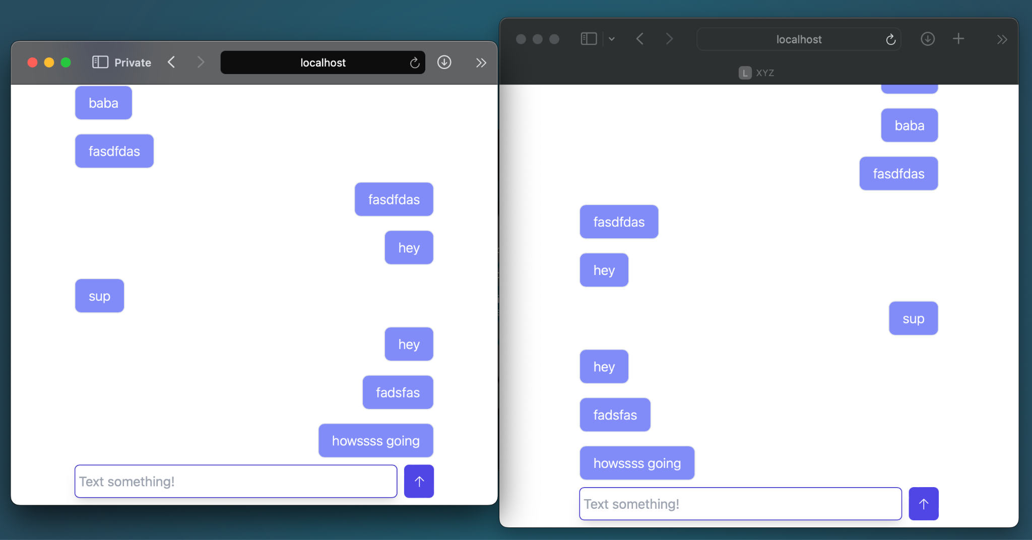

# Project Demo

## 6.1 Project Demo

Demo Link: <http://pyaesoneaung.com>

# Conclusion

## 7.1 Summary of Achievements

Throughout the development process, our team achieved significant milestones, bringing the envisioned web application to fruition. Key achievements include the successful implementation of a real-time chat application, enabling users to seamlessly send and receive messages. The integration of WebSocket technology further enhances the user experience by facilitating instant and responsive communication within the platform.

## 7.2 Challenges Faced and Overcome

While the project was marked by success, we encountered and successfully navigated several challenges. Technical difficulties and bugs posed initial hurdles, but our team's resilience and collaborative efforts allowed us to overcome these obstacles. Additionally, we faced occasional conflicts and disagreements, which were addressed through effective communication and a commitment to shared goals. Time management and prioritization were also areas of challenge, but we adapted our strategies to ensure the timely completion of planned features.

## 7.3 What Went Well

* **Feature Completion**: All planned features and functions were successfully implemented, providing users with a comprehensive and functional web application.
* **Team Collaboration**: The team collaborated effectively, fostering a positive and productive working environment.
* **Skill Development**: The project served as a valuable learning experience, allowing the team to acquire new technologies and skills.

## 7.4 What Was Challenging

* **Technical Issues**: Initial technical difficulties and bugs required thorough troubleshooting and problem-solving.
* **Team Dynamics**: Conflicts and disagreements within the team were challenges that demanded open communication and resolution.
* **Time Management**: Struggles with time management and prioritization were addressed through improved planning and coordination.

## 7.5 Future Improvement

Moving forward, we aim to enhance the user experience by allowing users to send various types of files through the real-time chat application. This addition will further broaden the platform's functionality and cater to diverse user needs.